TOURX PROJECT — GOVERNANCE TOOLBOX
CoVE Governance Structure Template
A practical tool for establishing effective governance frameworks
This template helps CoVEs define and document their governance structure. It provides a clear and practical framework that can be adapted to different regional contexts and stakeholder ecosystems.
1. Basic Information
Field | Information
CoVE Name | Insert CoVE name
Region / Country | Insert region or country
Organisation Leading the CoVE | Insert lead organisation
Date of Establishment | Insert date
Contact Person | Insert name
Email | Insert email address
Website (if applicable) | Insert website

2. Purpose of the Governance Structure
Describe the purpose of the governance structure and how it supports cooperation between education providers, tourism businesses, public authorities and other stakeholders.
3. Governance Model Overview
Governance Body | Role / Description
CoVE Steering Committee | Strategic direction and decision-making
Education Group | VET providers, universities
Industry Group | Tourism businesses, SMEs
Public Authority Group | Regional and national authorities
Working Groups / Operational Teams | Implementation of activities

4. Stakeholder Participation
Stakeholder Category | Organisation | Role | Participation
VET Providers
Universities
Tourism Businesses
Public Authorities

5. Roles and Responsibilities
Role | Responsibilities | Assigned Person / Organisation
CoVE Coordinator
Industry Representative
Education Representative
Public Authority Representative

6. Decision-Making Framework
Decision Type | Responsible Body | Approval Process
Strategic Decisions
Operational Decisions
Financial Decisions

7. Monitoring and Review
Indicator | Measurement Method | Review Frequency
Stakeholder participation
Governance effectiveness
Achievement of objectives

3. Governance Model Overview
Define and visualise the governance structure of the CoVE, including the main governance bodies, stakeholder groups and operational teams involved in the implementation of activities.
Instructions:
Insert a diagram of your governance structure. You can use the example below or adapt it according to your CoVE’s specific organisational context, regional ecosystem and stakeholder needs.
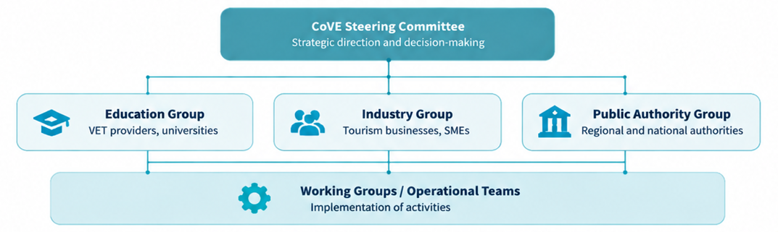
Governance Bodies Description
Governance Body | Main Responsibilities
CoVE Steering Committee | Provides strategic direction, oversees governance decisions and ensures alignment with CoVE objectives.
Education Group | Represents VET providers, universities and education stakeholders involved in skills development and training activities.
Industry Group | Represents tourism businesses, SMEs and sector representatives contributing to labour market alignment and skills needs identification.
Public Authority Group | Ensures coordination with regional and national policies, strategies and public stakeholders.
Working Groups / Operational Teams | Support the implementation of activities, cooperation actions and specific initiatives.

